# CS 340 README Template

## About the Project/CRUD in Python

This project performs simple “create”, “read”, “update”, and “delete” functions for the “AnimalShelter” class from the Python module ‘animal_shelter.py’. The Python module is accompanied by the python script ‘script.ipynb’ which modifies and queries the “AAC” database within MongoDB based on the results returned by the script and module.

## Motivation

This project enables the development of a web application that connects a client-side user interface (i.e., a dashboard) to a database.

## Getting Started

This project assumes you have a MongoDB already setup and are familiar with Mongo shell commands as well as any OS shell commands you may need and/or import the project files. This project also assumes you have properly setup authentication with a username and password for the database “AAC”; thus, if you are using this project for your own database, please insert your own username, password, and database name as well as the correct IP and port number for the Mongo client in their respective files.

***Additionally, be sure to place the ‘animal_shelter.py’ and ‘script.ipynb’ files in the same folder.***

## Installation

The tools used in this project:

* Ubuntu Linux is the operating system and server being used and, therefore, the Linux terminal is used to manage the Mongo server connections, importing of .json and .csv files for the database, and Mongo user authentication
* MongoDB houses the database and database user authentication
* Python is the programming language being used which you will need to run the Python module and Python script files.
* Jupyter Notebook is used for running the ‘animal_shelter.py’ module and the script file ‘script.ipynb’;

**Downloads**

Ubuntu Desktop: <https://ubuntu.com/tutorials/install-ubuntu-desktop#1-overview>

Ubuntu Server: <https://ubuntu.com/tutorials/install-ubuntu-server#1-overview>

MongoDB: <https://docs.mongodb.com/manual/installation/>

Python (Linux): <https://www.python.org/downloads/source/>

Jupyter Notebook: <https://jupyter.org/install>

## Usage

This project may be used for connecting a user interface component to a database component of a dashboard or other client-side user interfaces. This project may also be used to confirm the success of that connection.

### Code Example

Once the new data to be inserted has been defined and the username and password have been entered into the “AnimalShelter” class object in the script file, the new data is created and read with the following code (some variable names have been changed to accentuate functionality):

**COLOR KEY:**

**------------------------------------------------------------------------------------------------------------------------------------------**

Black: definitions, dictionaries, filters

Orange: variables to be used as arguments

Purple: variables to be used as function calls and outputs

Red: class object

Green: methods, constructor

Blue: comments

**CODE:**

# class object defined as ‘classObject’

user = ‘yourUser’

pw = ‘yourPW’

classObject = AnimalShelter(user, pw)

# define data, note 2 animals were defined with same id intently

newData1 = { “animal_id” : “123456”, ”name” : ”Whiskers” }

newData2 = { “animal_id” : “123456”, “name” : “Mittens” }

newData3 = { “animal_id” : “456789”, “name” : “Fluffy” }

bulk_create = [ newData1, newData2, newData3 ]

# call create method, takes two args → (data, option)

# data should be a dictionary, option should be “one” OR “many” without quotes

one_creation = classObject.create(newData1, one) # create one dictionary of data

many_creations = classObject.create(bulk_create, many) # create many dictionaries of data

print(one_creation)

print(many_creations)

# call read method, takes two args → (data, option)

# data should be a dictionary, option should be “one” OR “many” without quotes

search = { “animal_id”: “123456” }

one_read = classObject.read(search, one) # read one document

many_reads = classObject.read(search, many) # read many documents

print(one_read)

print(many_reads)

# call read method, takes three args → (doc_to_update, field_to_update, option)

# doc and field to update should be a dictionary, option should be “one” OR “many” without quotes

doc = { “animal_id”: “123456” } # define document filter

field = { “color” : “White” } # define field filter

one_update = classObject.update(doc, field, one) # update one document

many_updates = classObject.update(doc, field, many) # update many documents

print(one_update)

print(many_updates)

# call delete method, takes two args → (doc_to_delete, option)

# doc_to_delete should be a dictionary, option should be “one” OR “many” without quotes

delete_this = { “animal_id”: “123456” } # define document filter

# many_removals could either be used to initially delete many documents defined by filter,

# or act as a cleanup function to delete any unintentional copies of documents defined by filter

one_removal = classObject.delete(delete_this, one) # delete one document

many_removals = classObject.delete(delete_this, many) # delete many documents

print(one_removal)

print(many_removals)

**------------------------------------------------------------------------------------------------------------------------------------------**

**END CODE**

### Tests

To Run the script, simply click the “Run” button in Jupyter. You should see results beneath the script such as “One document read: True”, “Read Successful”, and “<pymongo.cursor.Cursor object at 0x7ff............>”. Otherwise, you may also see exception message(s) with some feedback such as your data and/or search parameters being empty.

To verify the data was added to the database:

* Start your MongoDB in the Linux shell
* Authenticate into the MongoDB shell using the same username and password specified in the Python script file and using the same IP, port number, and database as specified in the Python module file
* In MongoDB, switch to use the database specified by the Python module file
* Navigate to the collection that houses the database and run the ‘find’ command to verify the search criteria you specified in the Python script file. The result should be the return of the new data you entered in the same Python script file.

### Screenshots

The screenshot above displays the successful import of ‘aac_shelter_outcomes.csv’ into MongoDB.

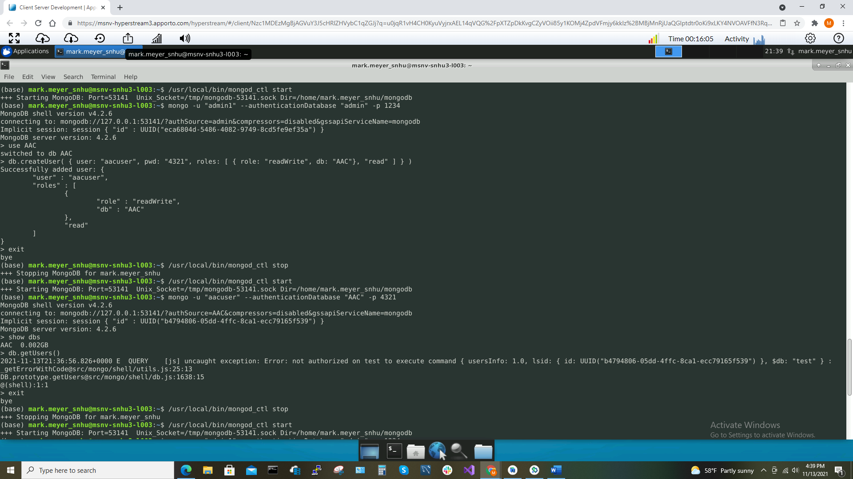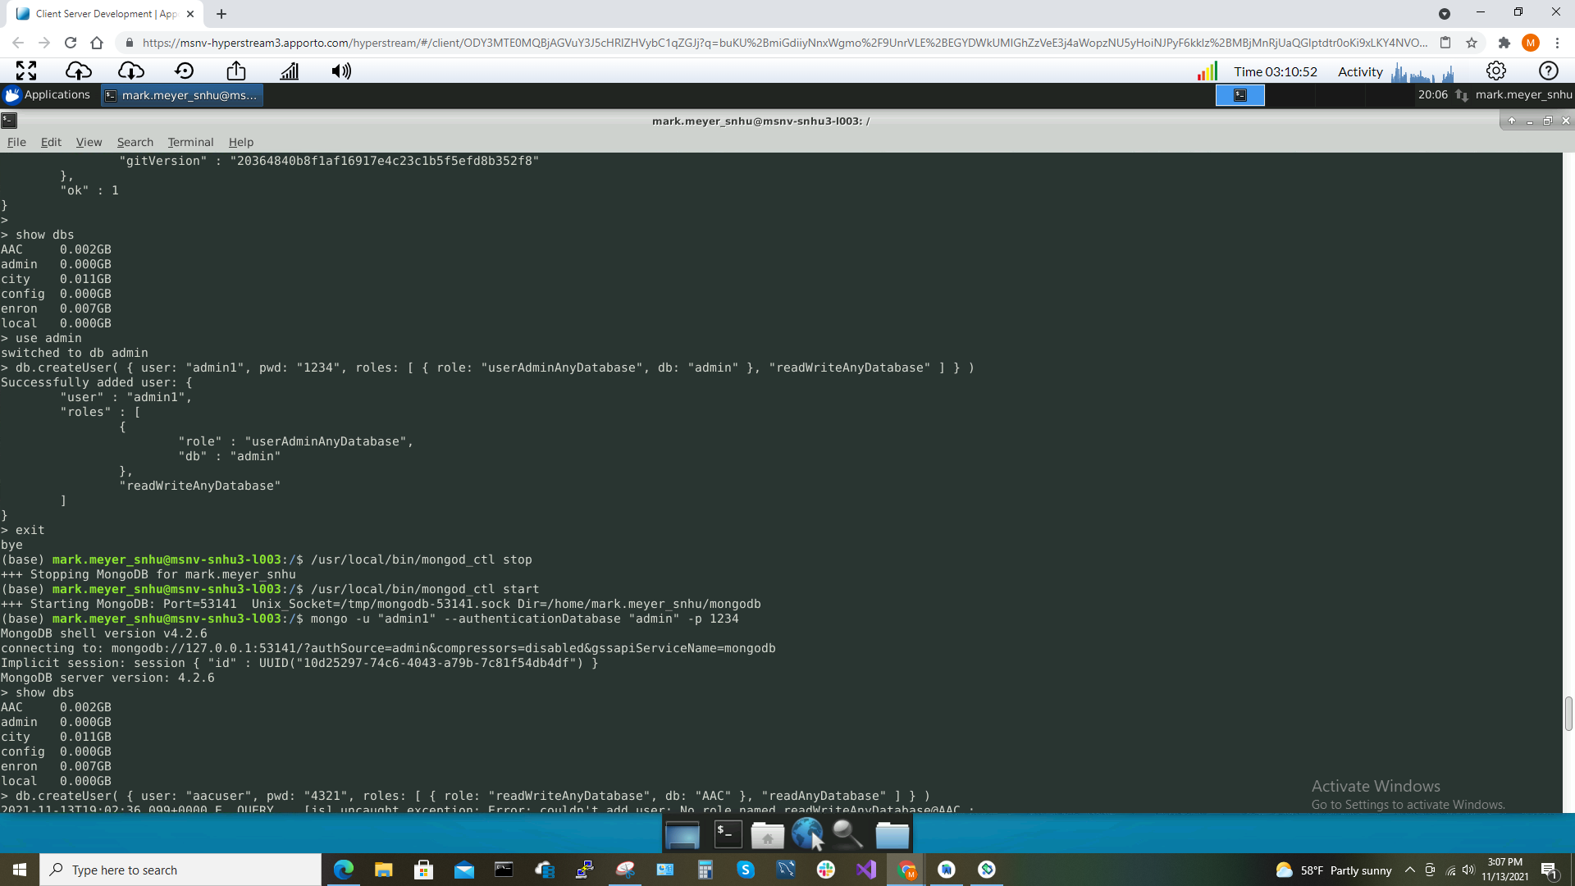

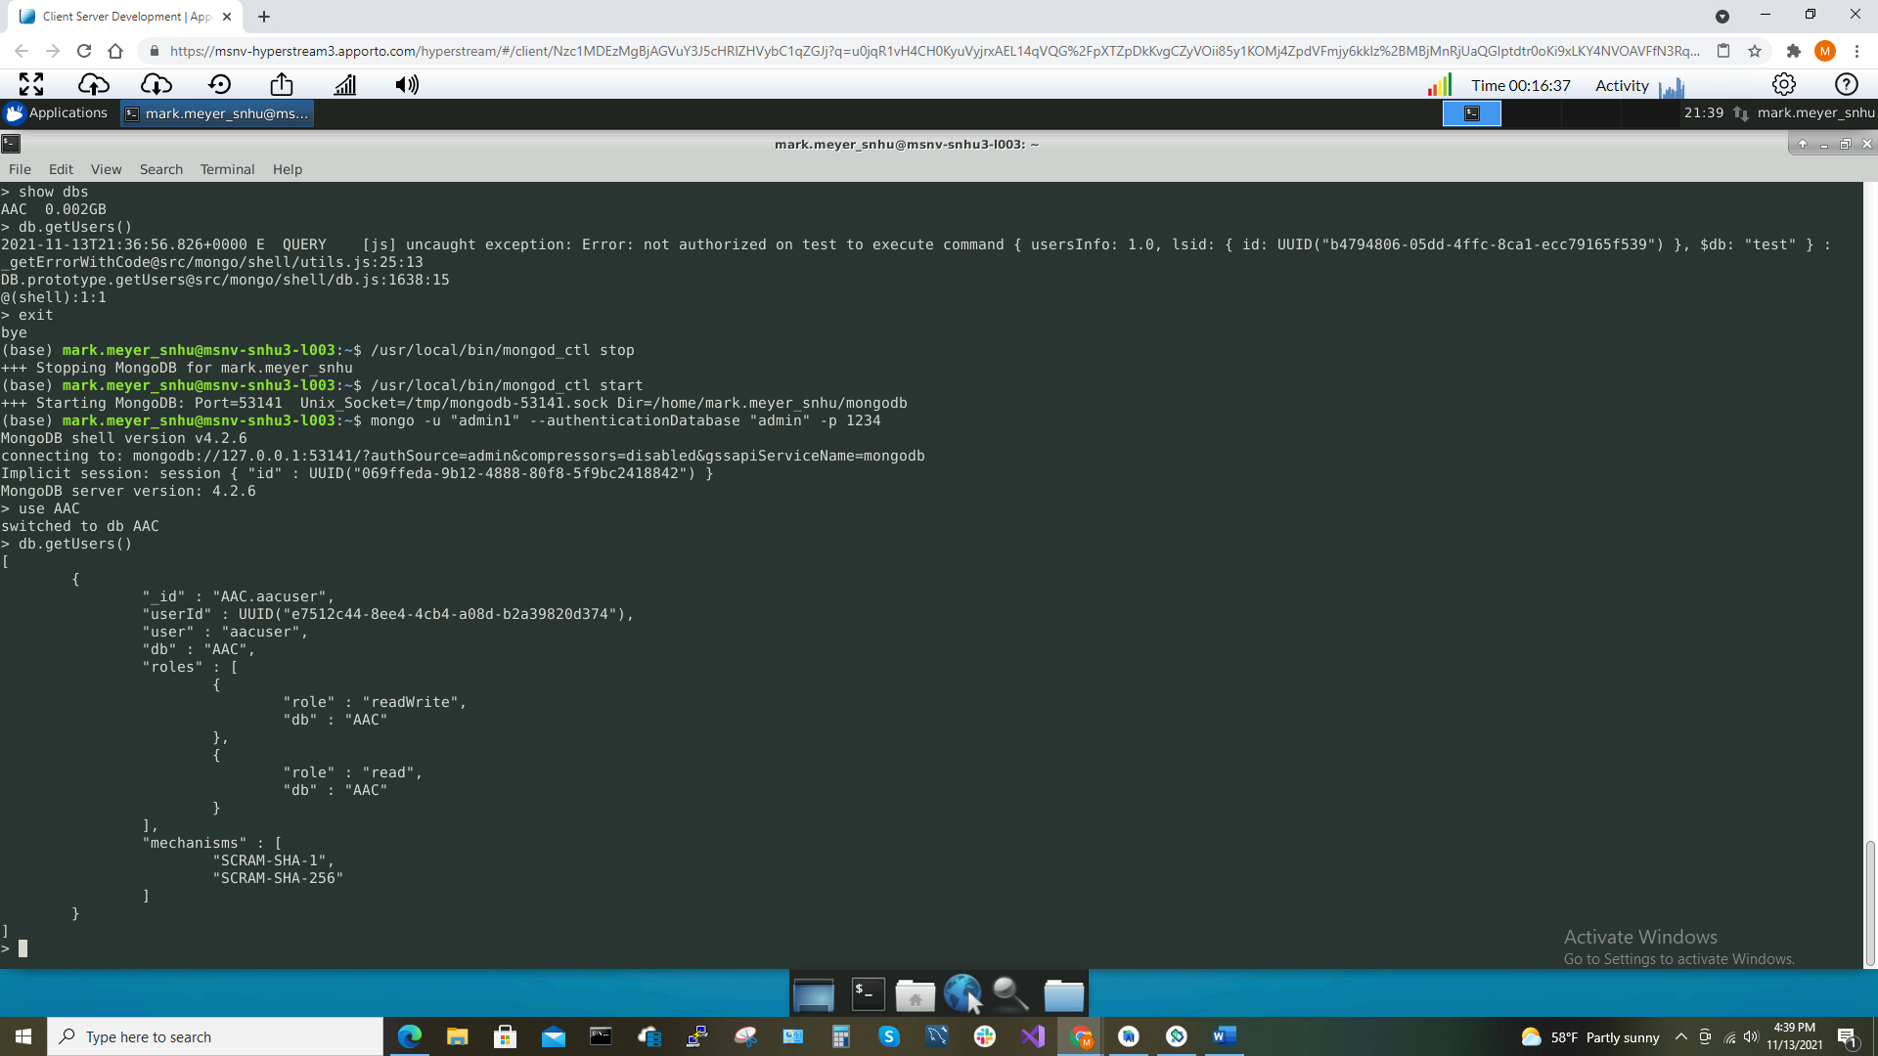

The 3 screenshots above display the successful creation of the admin user and read/write-only user ‘aacuser’ whom only has the permission to read and write from/to database ‘AAC’ respectively.

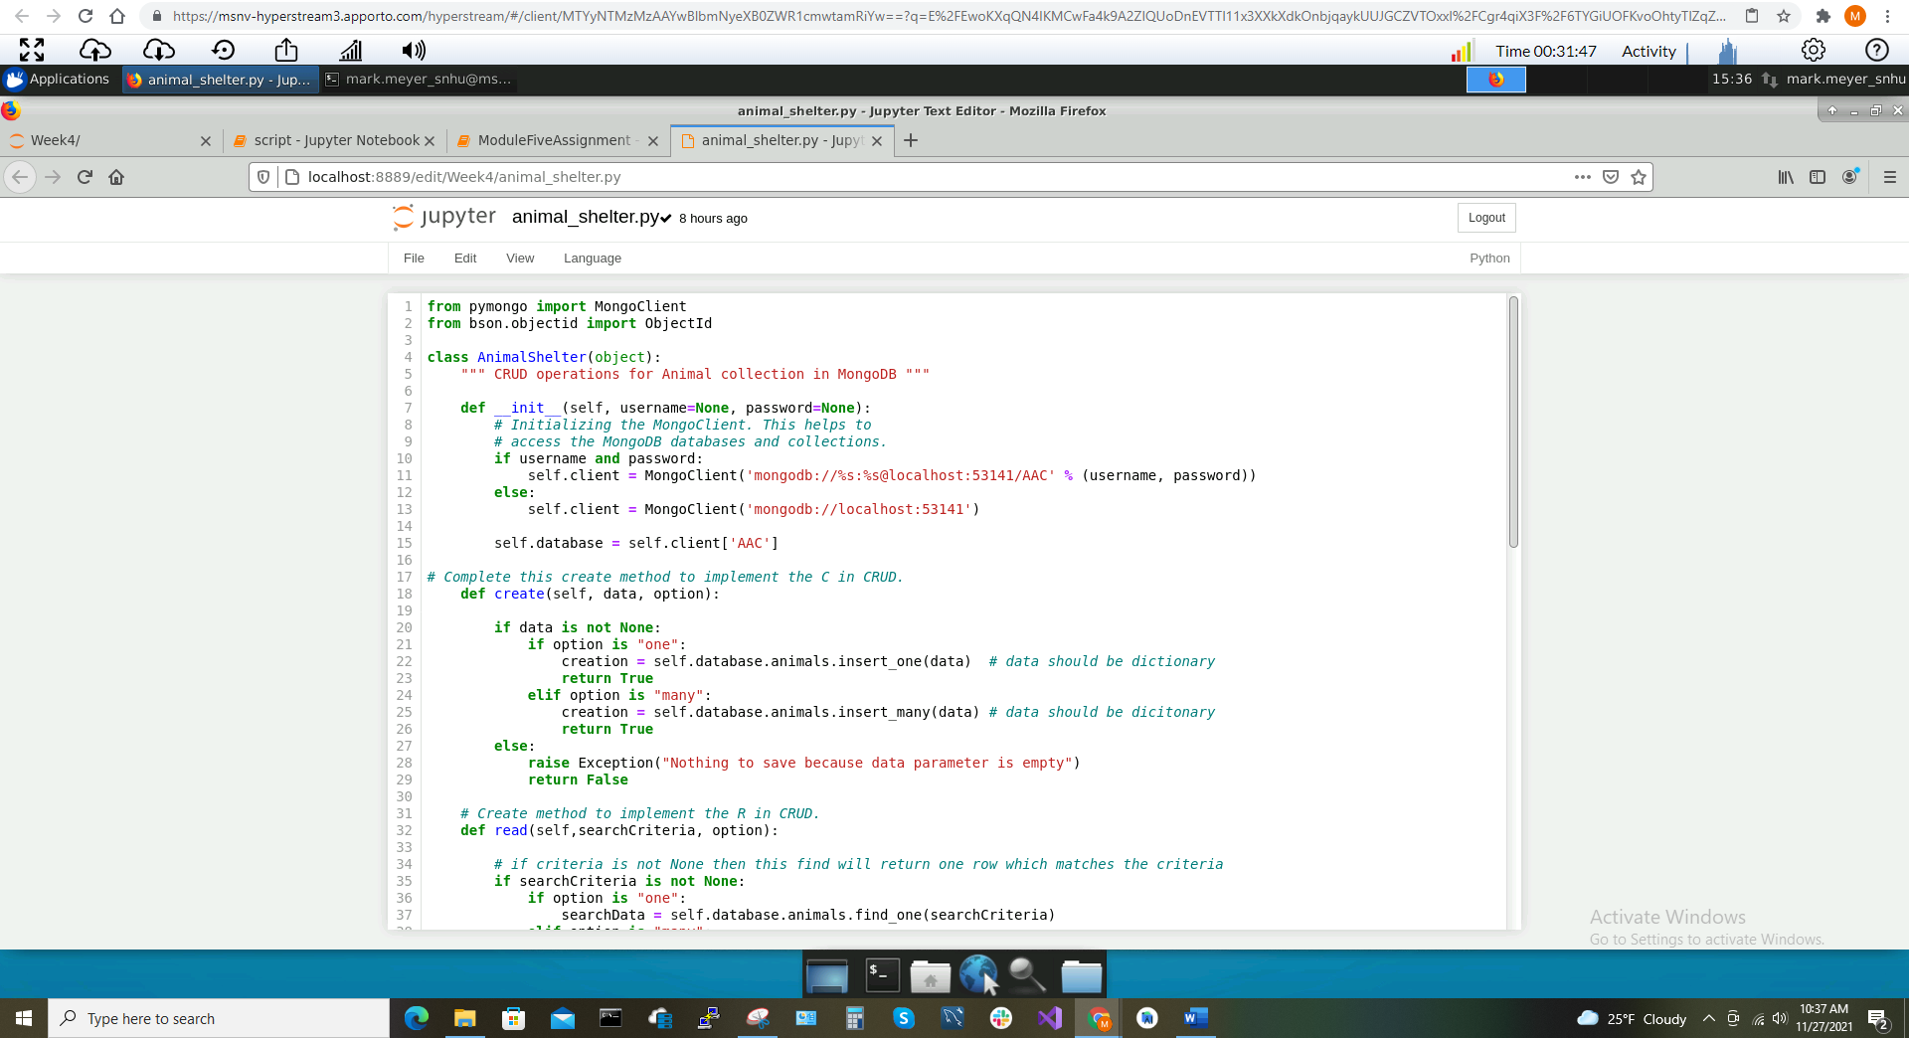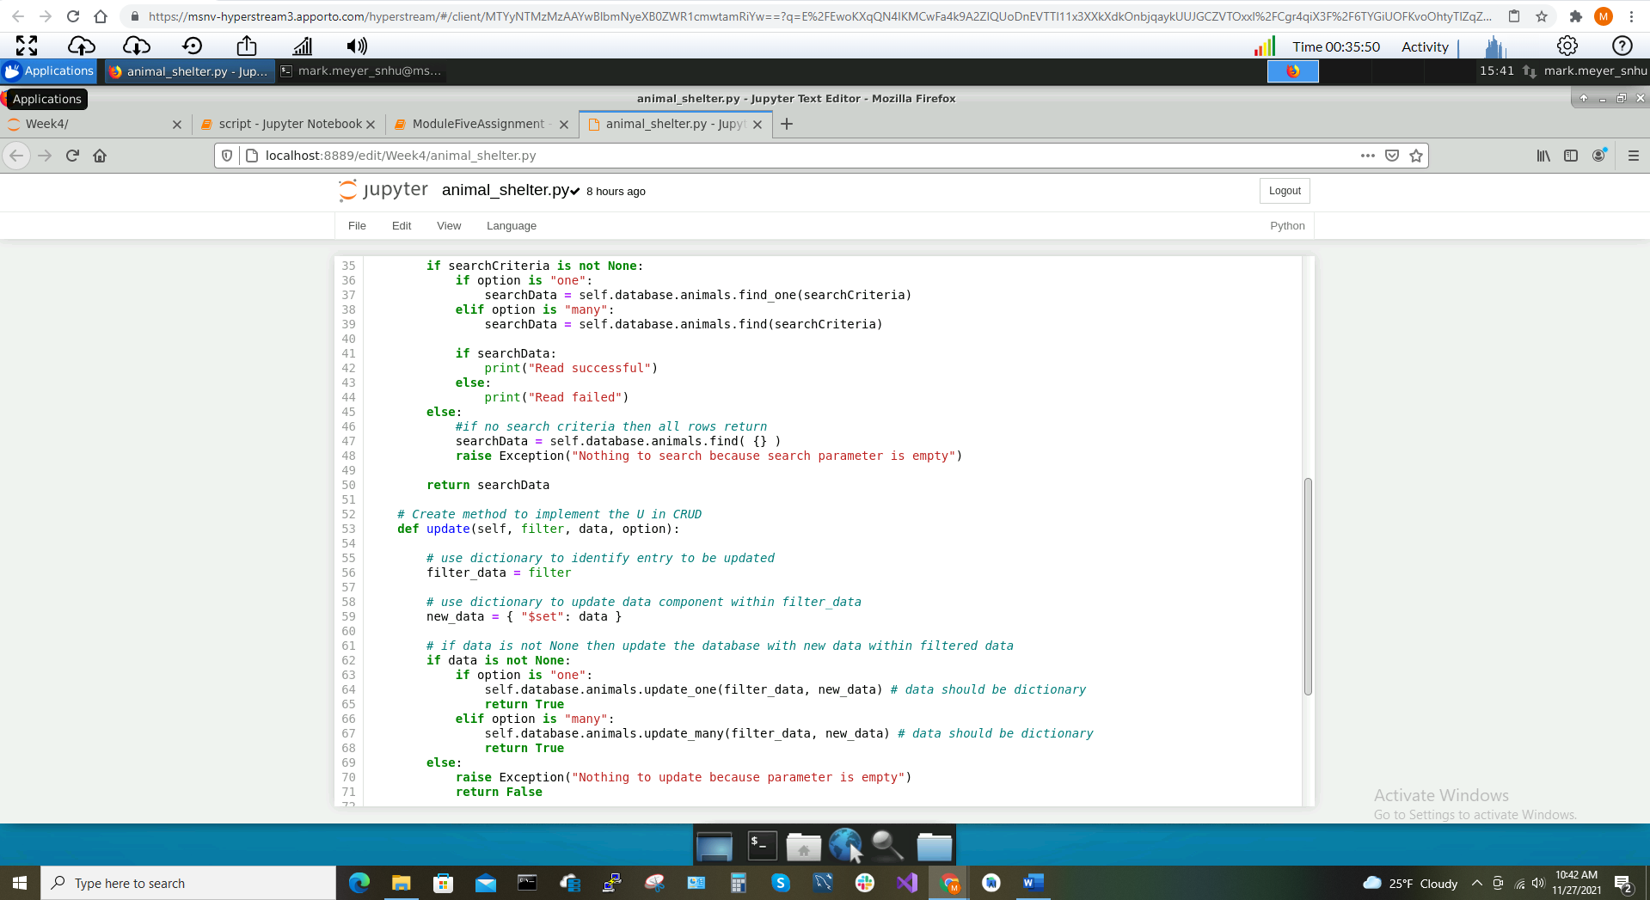

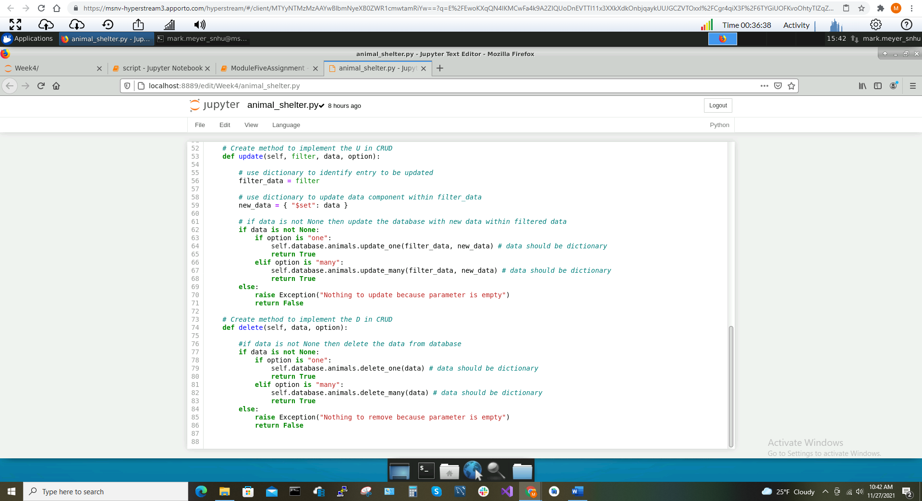

The 4 screenshots above display the Python module ‘animal_shelter.py’ which is imported into the Python script ‘script.ipynb’. Within this module, we define the Mongo client connection, port, database, CRUD methods, exception handling, and user feedback upon success and failure of each method. Note the handling of the ‘option’ parameter which determines whether each CRUD operation performs an action on a single entry or many entries.

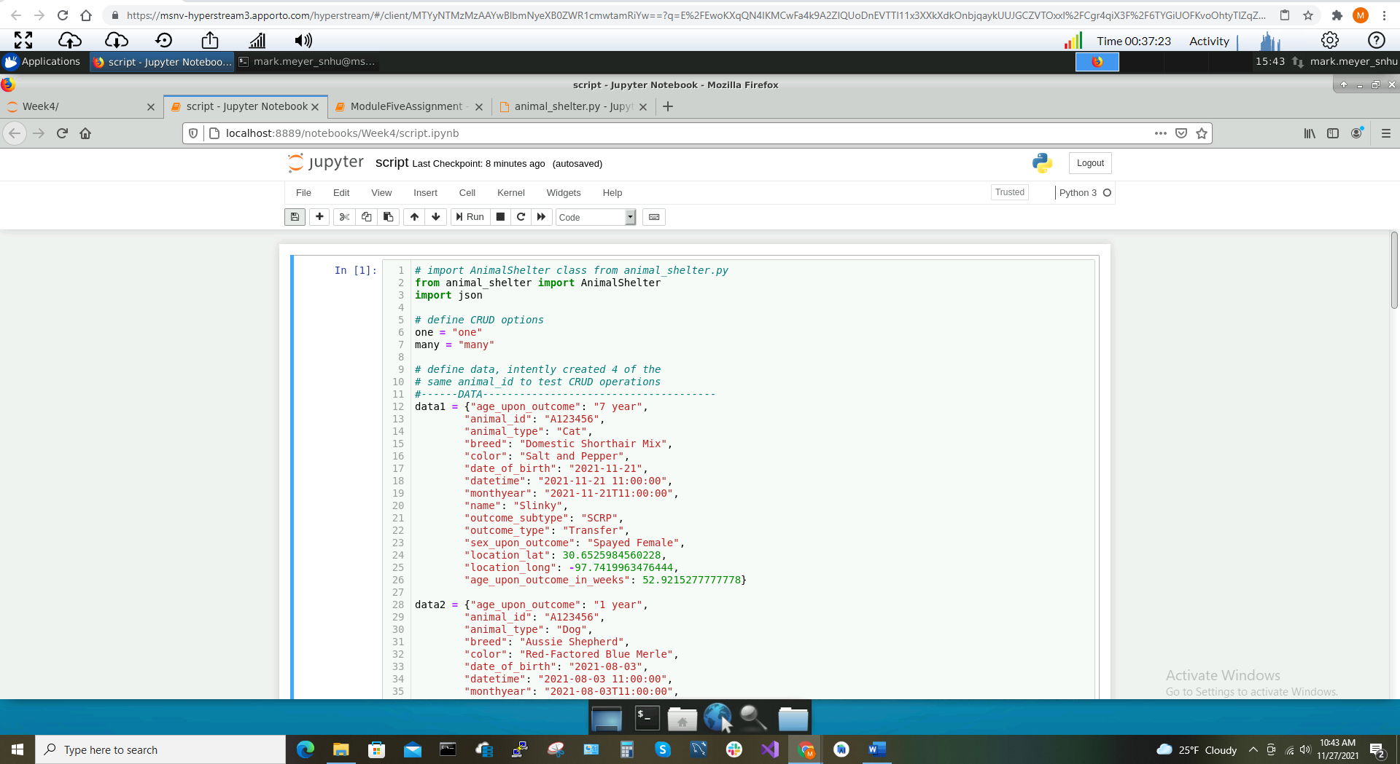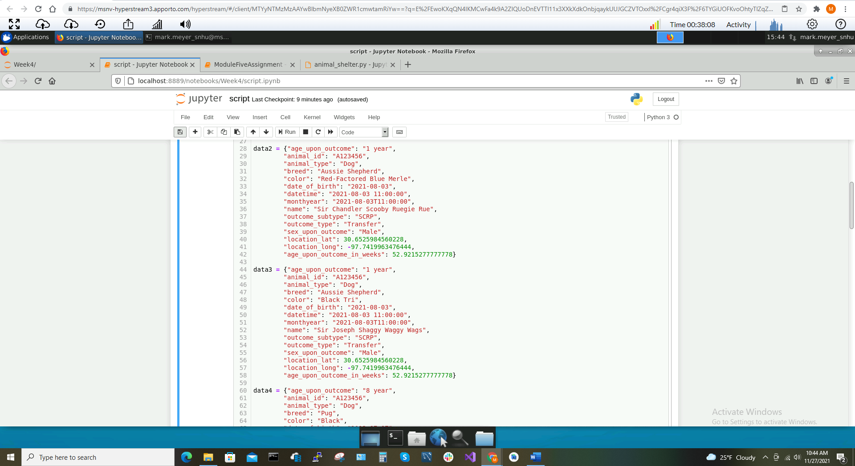

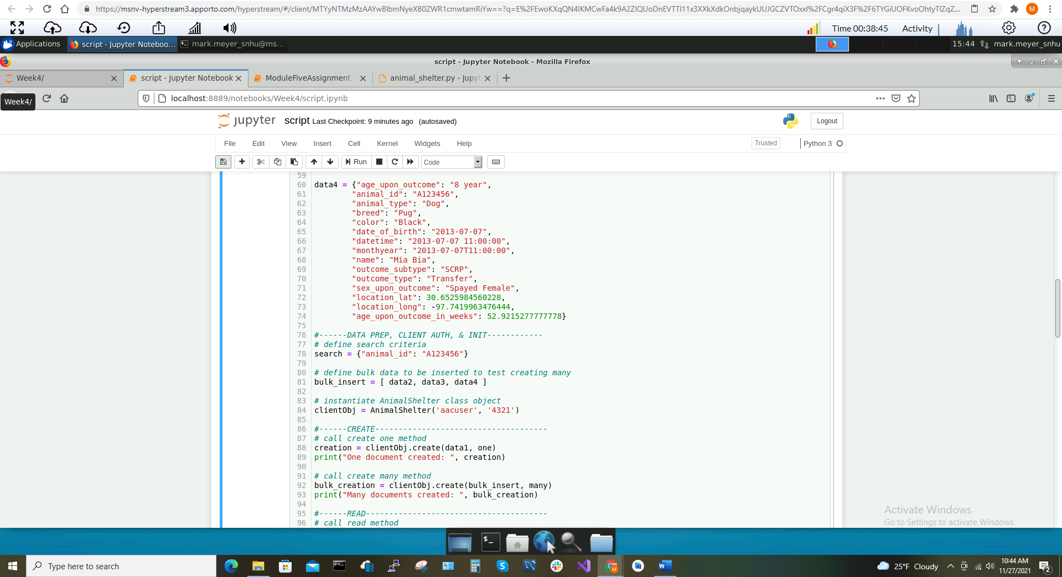

We look now in the Python script file ‘script.ipynb’. In the 3 screenshots above, we import the Python module, ‘animal_shelter.py’, define the strings for the ‘option’ parameter, define the documents as dictionaries, define a search filter, define a list of dictionaries for a bulk creation of data, define the client’s class object using the username and password for authentication to the MongoDB server, and finally define the first CRUD operation for ‘Create’. Notice we call both ‘create’ options to create ‘one’ document and to create ‘many’ documents.

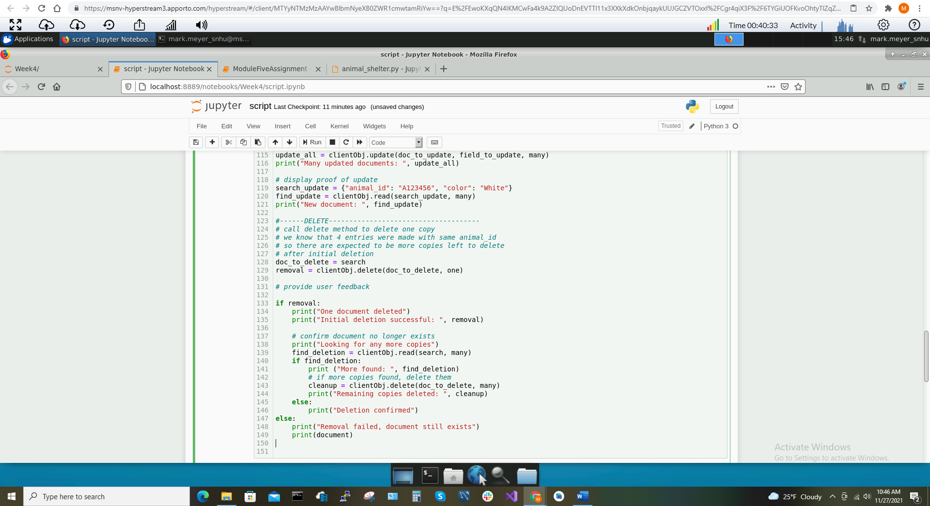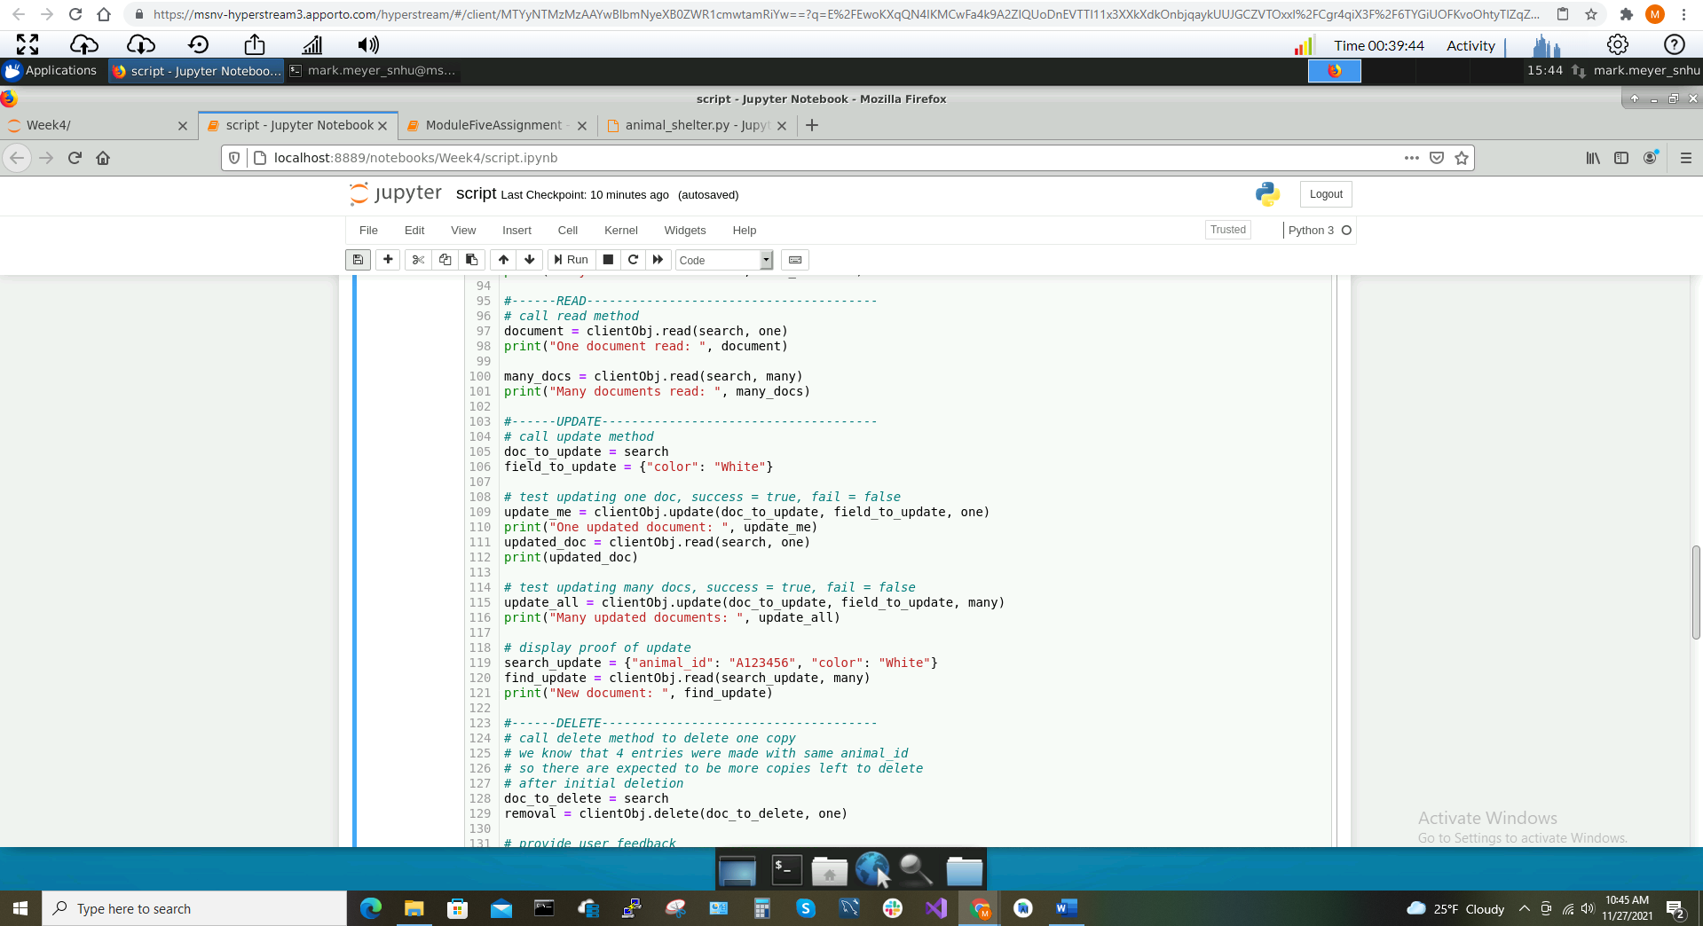

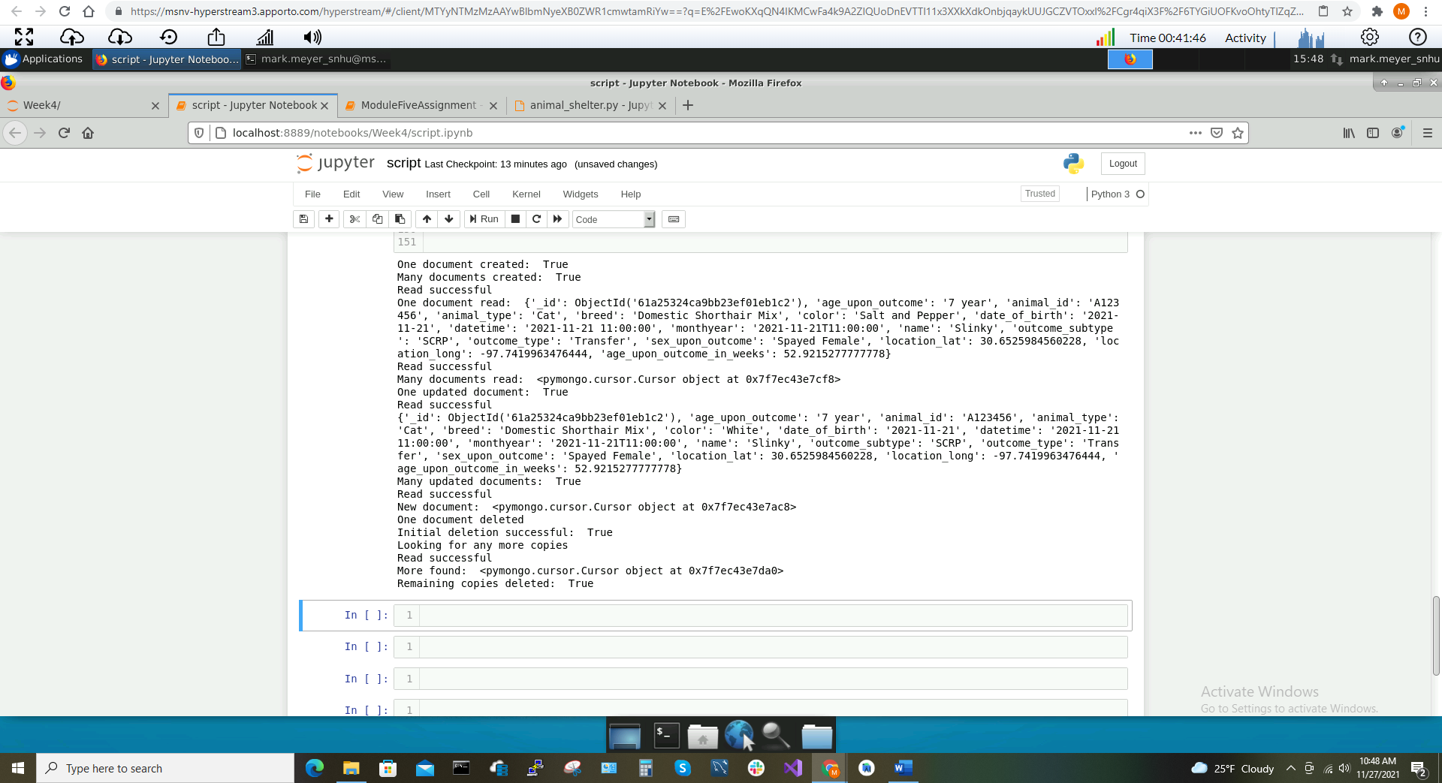The 2 screenshots above convey the testing of the remaining 3 CRUD operations: ‘Read’, ‘Update’, and ‘Delete’. Each CRUD operation takes the ‘option’ parameter which allows the operation to perform an action on one or many documents. The data to be manipulated by each CRUD operation is defined by a dictionary passed as a filter argument. In the case of the ‘Update’ method, you must define both the document and the field in their respective dictionaries alongside the option parameter. In this case, multiple copies were made of the data using the same ‘animal_id’. We see in the ‘Delete’ function the use case where the ‘many’ option is utilized to clean up any remaining copies missed by the option to delete ‘one’.

In the screenshot above, we see the overall output when this script runs all 4 CRUD operations at once. In order, the script does the following: creates one document and prints it; creates three documents and prints the memory location, reads one document, reads all 4 documents with the ‘animal_id’ “A123456”; updates one document and prints it; updates the color to ‘White’ of all 4 documents with ‘animal_id’ “A123456” and prints the memory location; deletes one document with ‘animal_id” “A123456”, then looks for more copies, finds more documents with the same id, then deletes those documents.

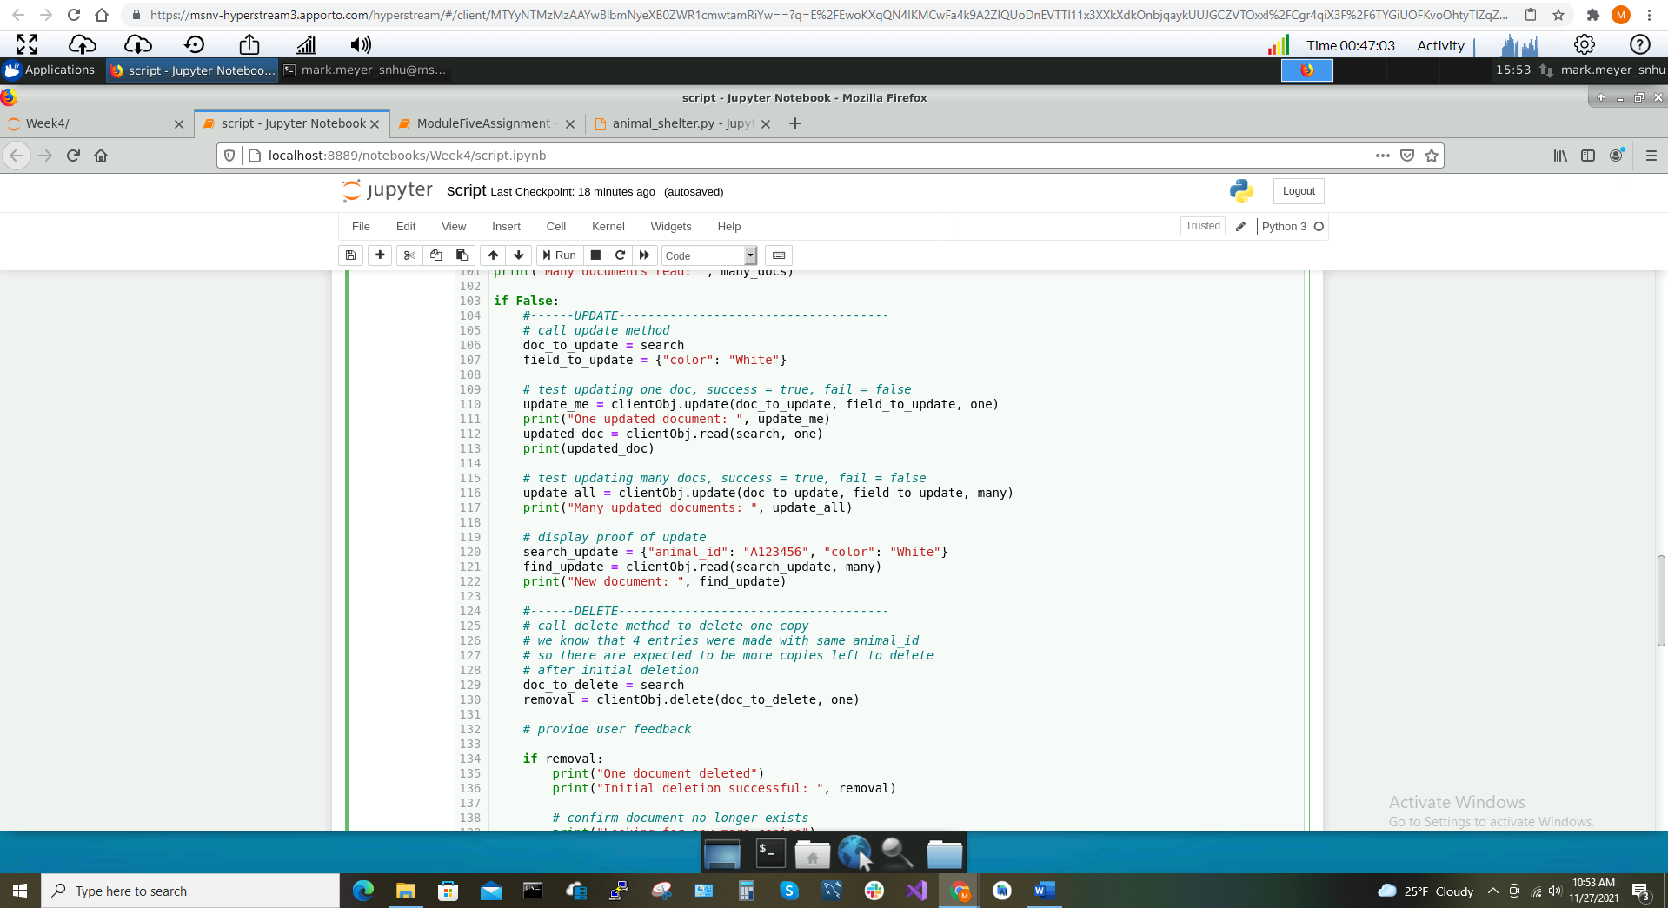

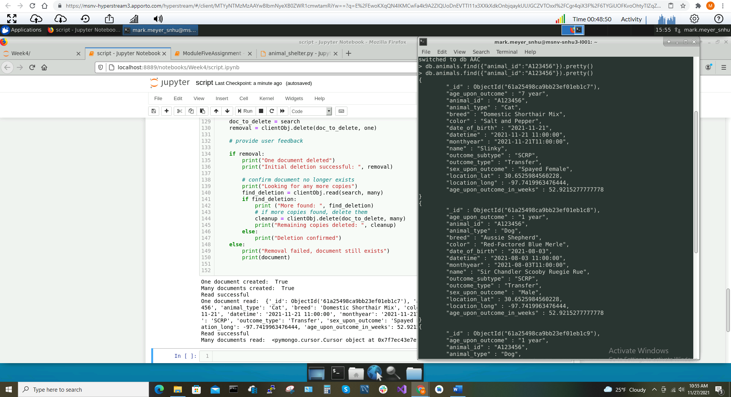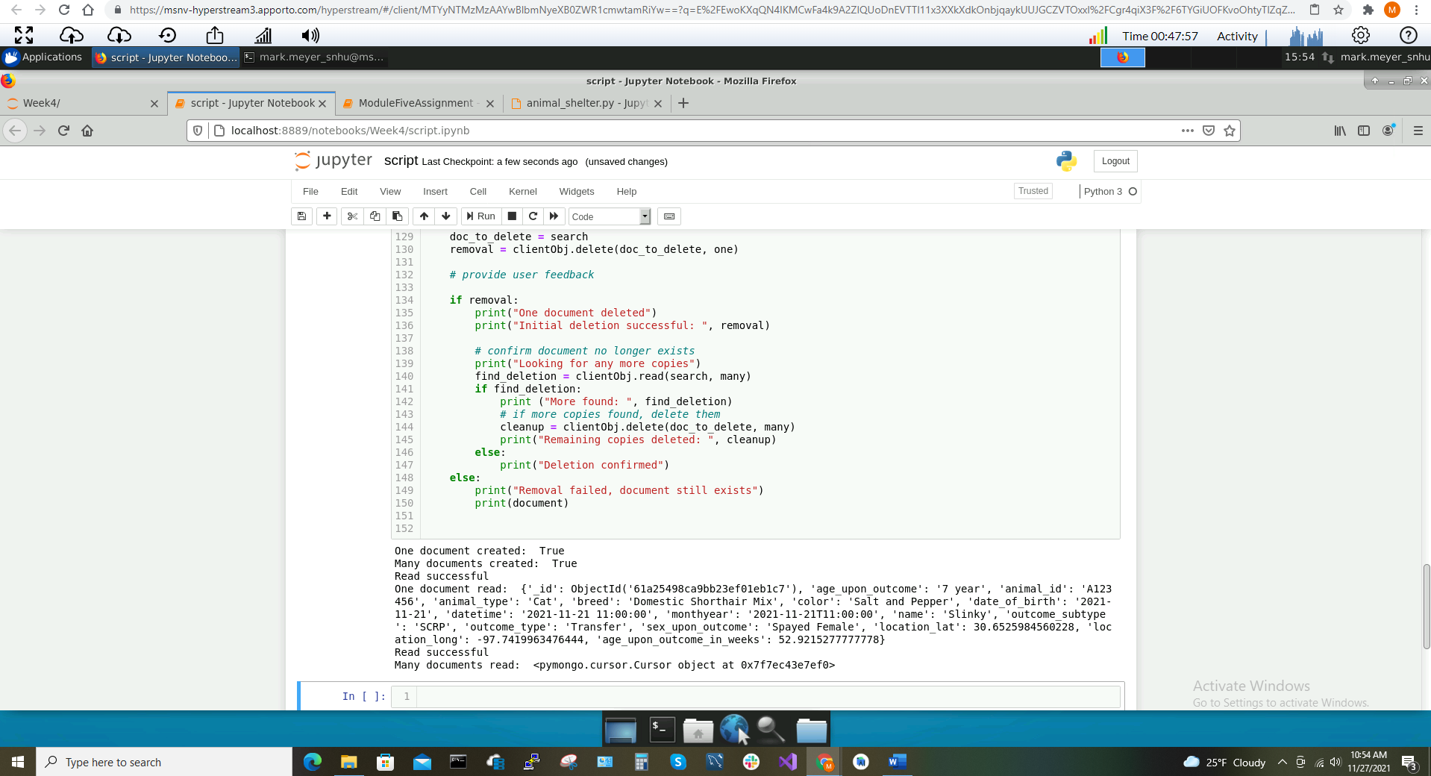

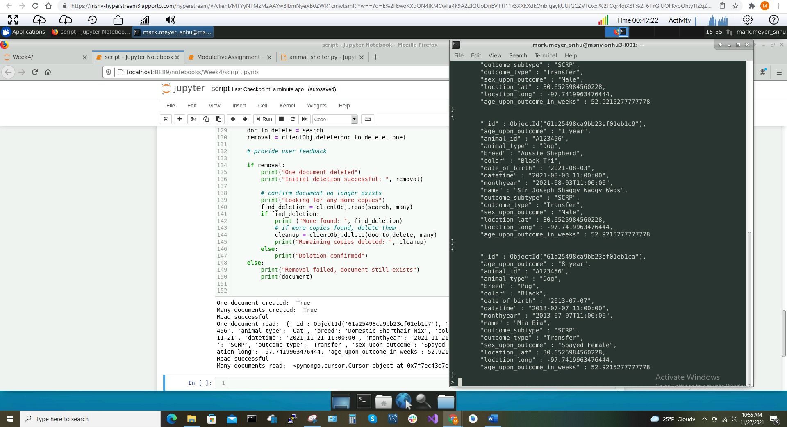

Now, we look at the Python script and module working to update Mongo by commenting out functions and watching the functionality take place step-by-step. In the 4 screenshots above, we begin in the first two screenshots by commenting out the ‘Update’ and ‘Delete’ code blocks by adding the ‘if False’ condition at line 163. Notice the corresponding output for the ‘Create’ and ‘Read’ functions in the second screenshot. In the third and fourth screenshots above, my first call to ‘find’ was ran before I ran the script to verify the data did not already exist in the database. Then, after running the script, we can see the successful creation of all 4 documents inserted into the Mongo database.

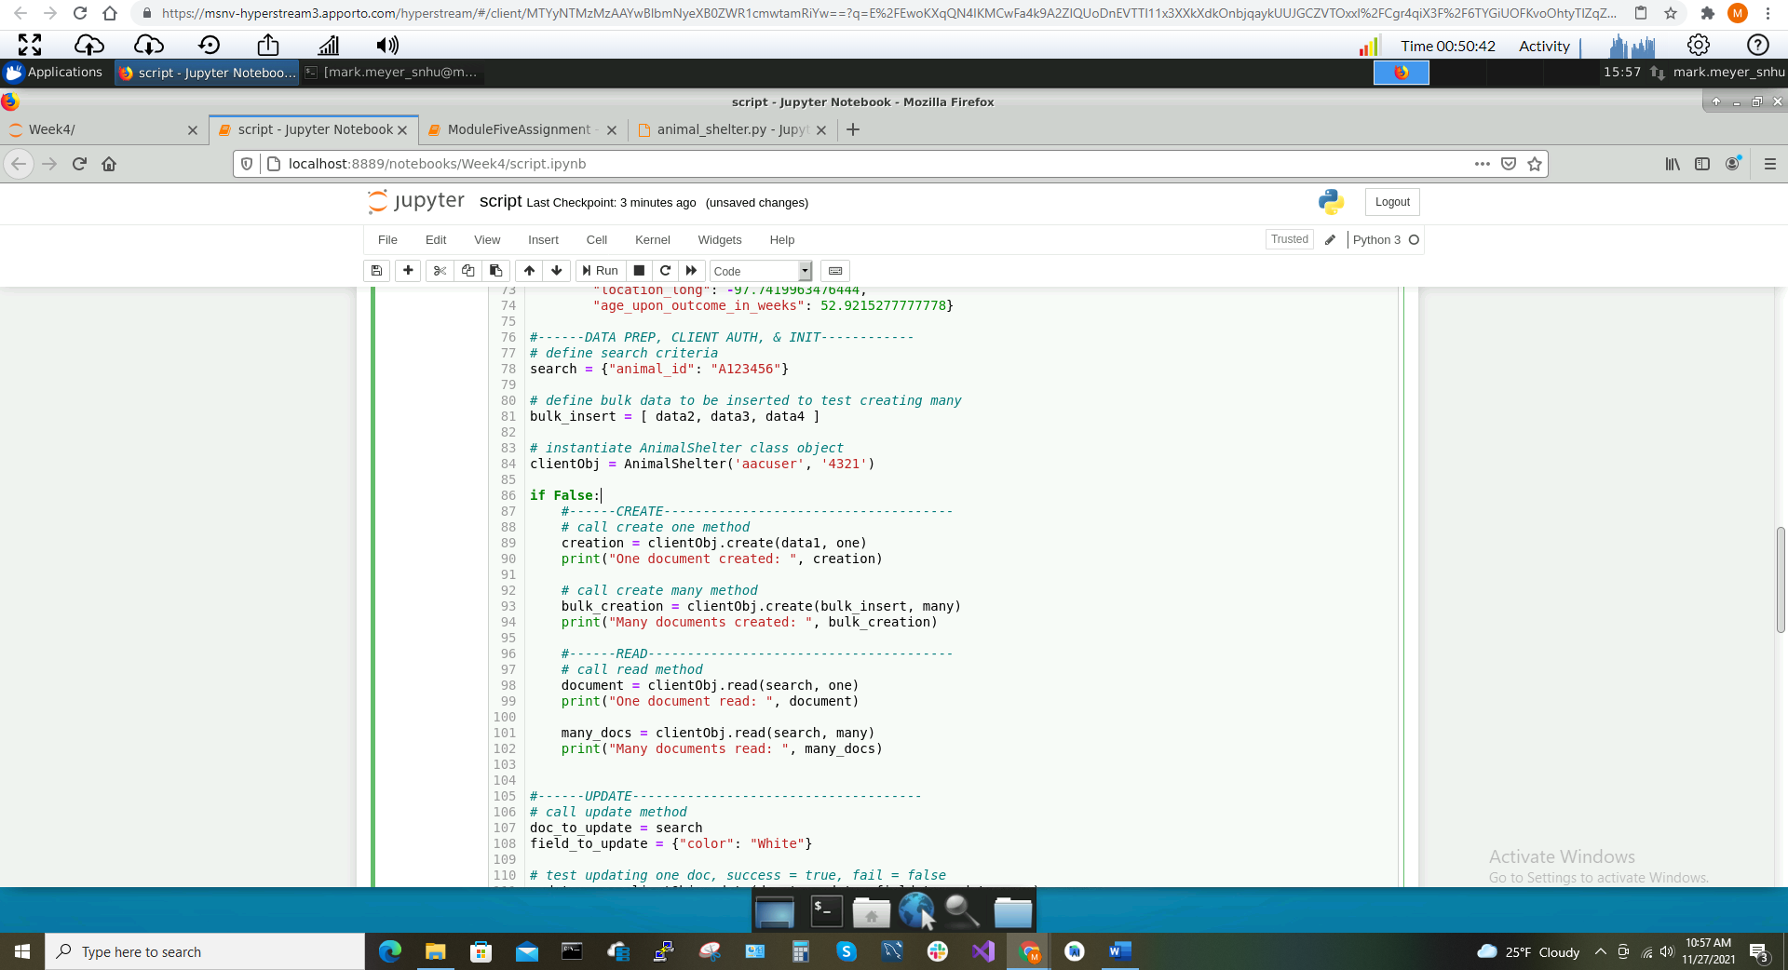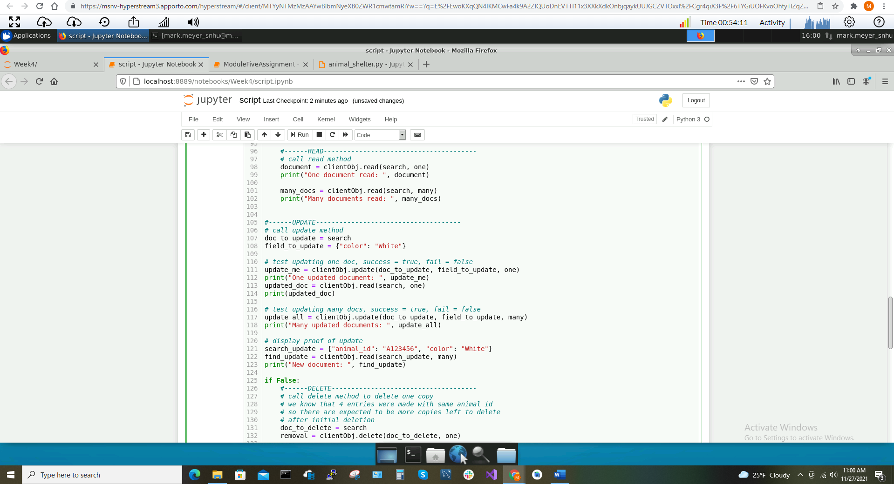

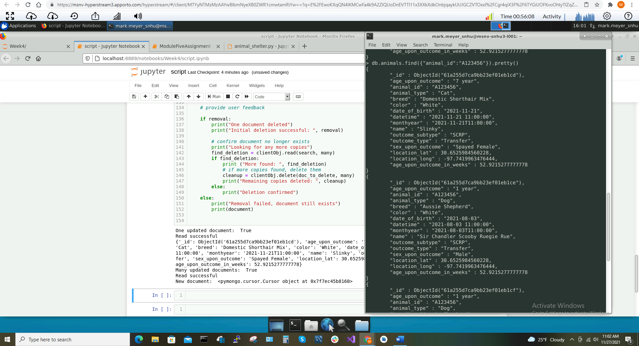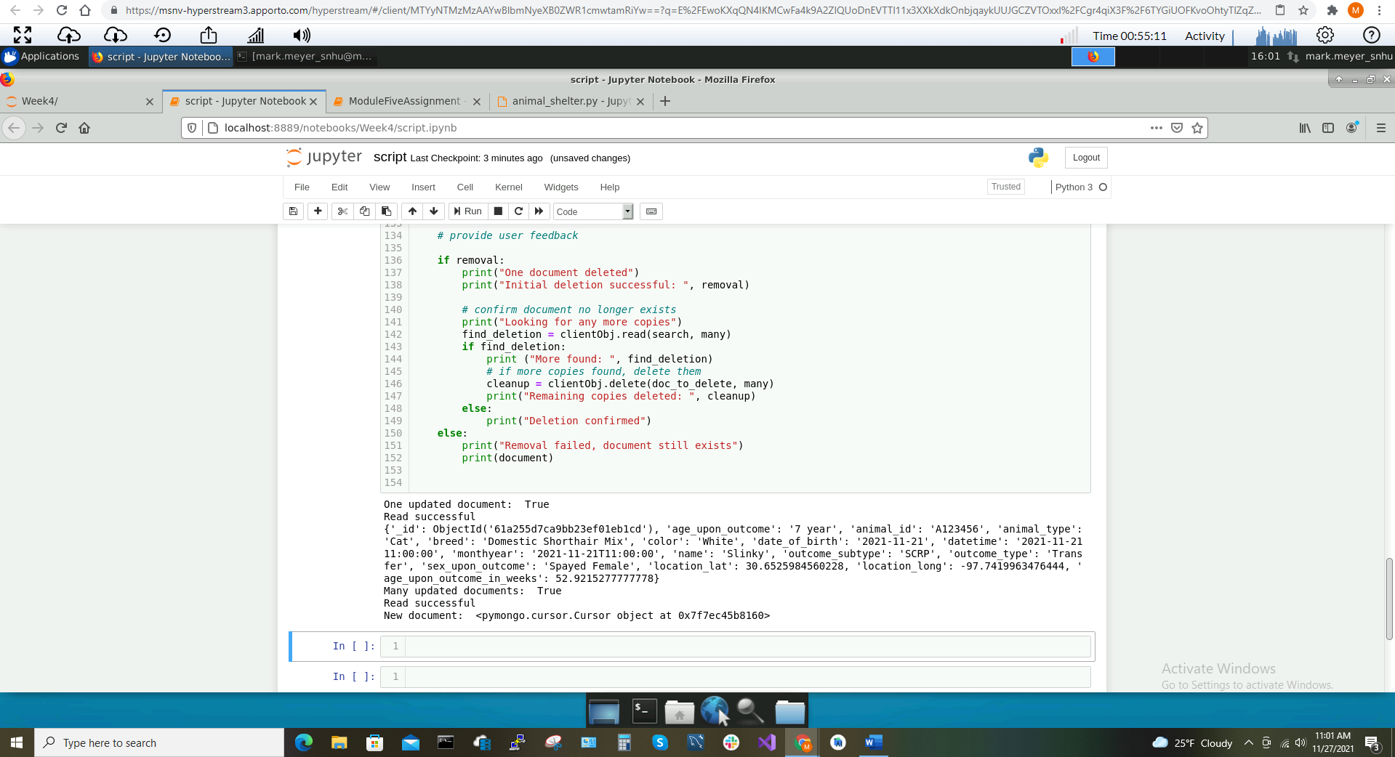

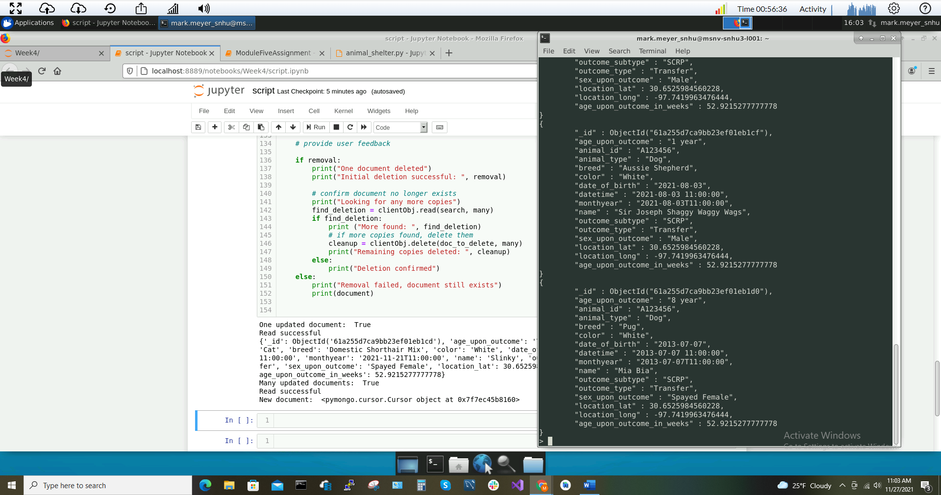

In the 5 screenshots above, we see the testing of the ‘Update’ CRUD operation. The first two screenshots show the commenting out of the ‘Create’, ‘Read’, and ‘Delete’ functions. The third screenshot show the module output for the updates of one and many documents. Since this output prints out the single updated document, I did not show this update in the console by itself. You can see by the output the successful update of the color field. The fourth and fifth screenshots display the successful update of the color field for all 4 documents with the “animal_id” “A123456”.

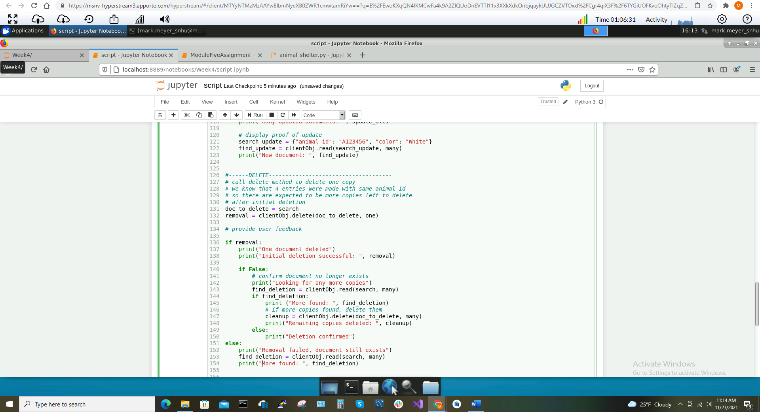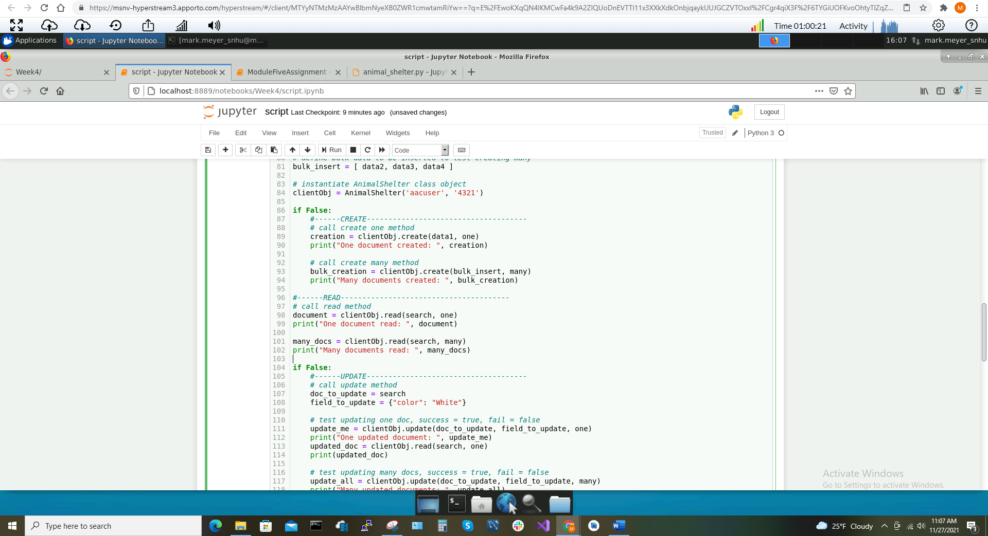

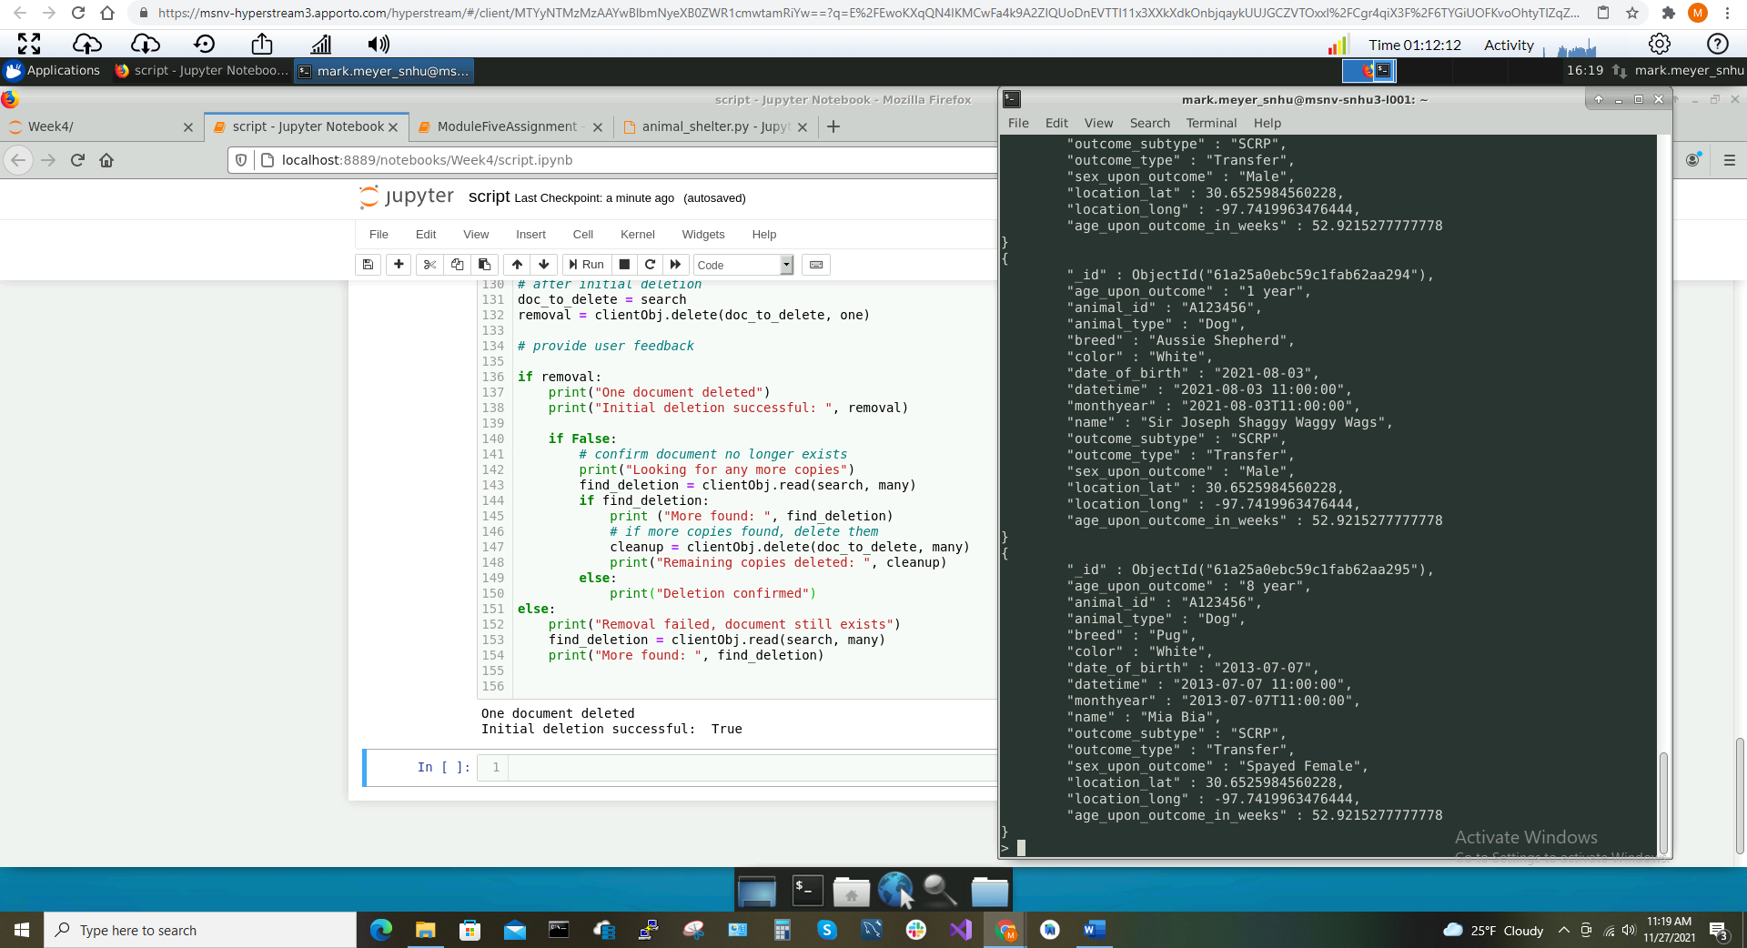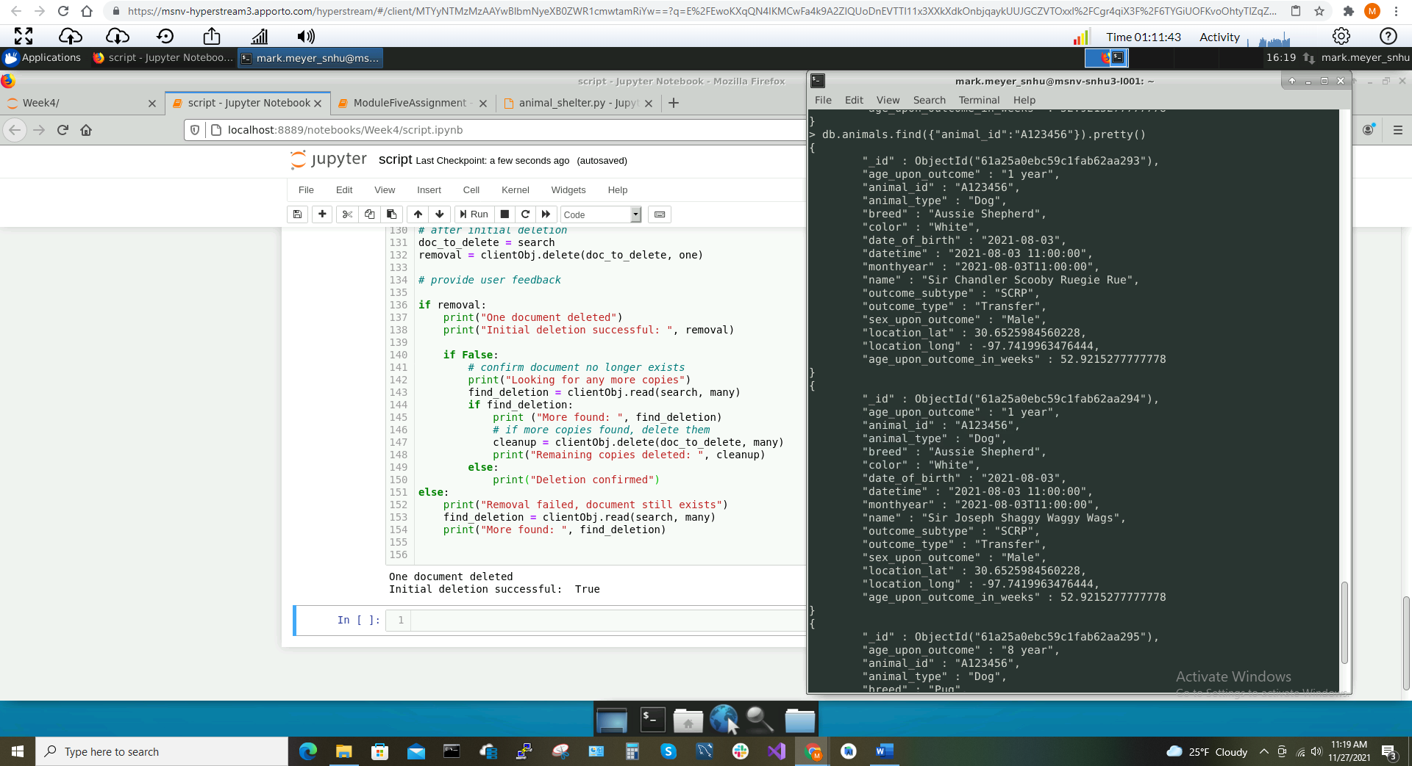

The 4 screenshots above display the successful console output of the ‘Delete’ CRUD operation. In the first two screenshots, we comment out the ‘Create’ and ‘Update’ functions as well as the ‘cleanup’ functionality which utilizes the ‘many’ option for the ‘delete’ method. This is to confirm the successful initial deletion of a single document. In the third and fourth screenshots, we see the module is run, the initial deletion is reported to be successful, and the console now shows 3 of the 4 original documents remaining in the database with the “animal_id” “A123456”.

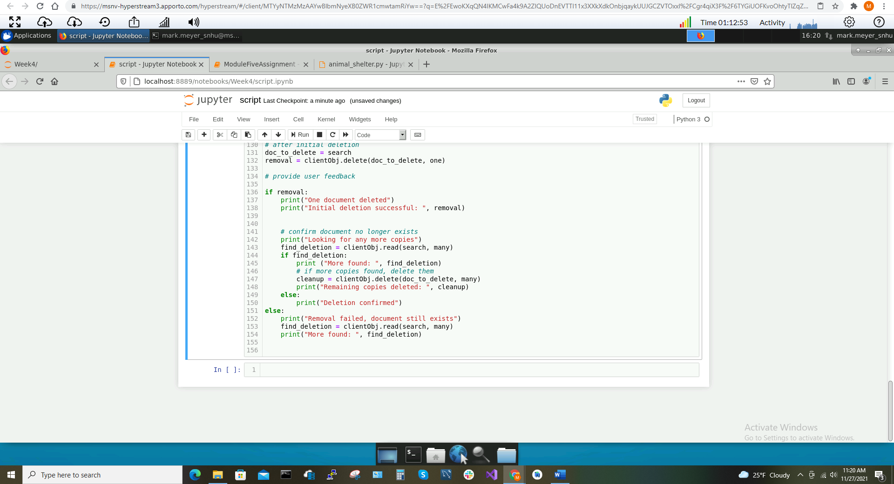

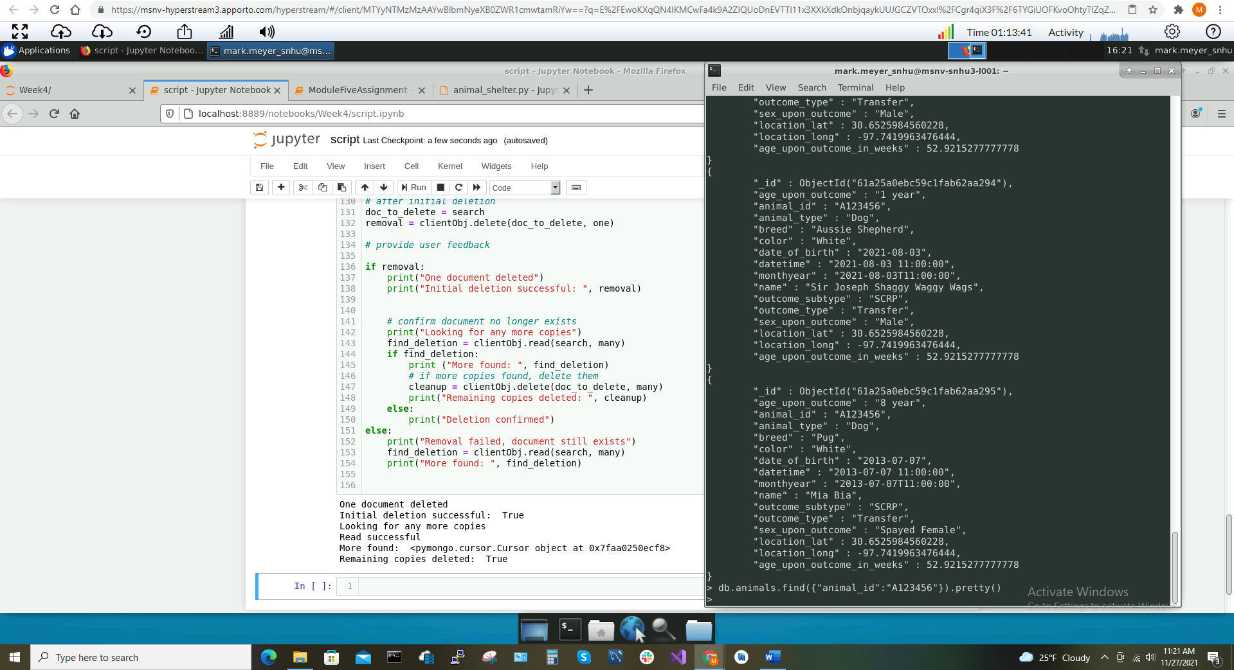

In the 2 screenshots above, we remove the ‘if False’ from line 140 to reinstate the ‘delete many’ cleanup functionality of the ‘Delete’ CRUD operation. Subsequently, we run the script, which inadvertently deletes one more document—this leaves two of the four documents left to search for—then deletes the remaining documents with the “animal_id” “A123456” successfully. We in the console that the command to find these documents returns nothing because they no longer exist in the database.

***This concludes the Python module and script testing for all 4 CRUD operations.***

As you can see in the screenshots above, I was able to create data, define my search criteria, then use the class object to authenticate to the Mongo server and use that client object to enable the success of basic CRUD operations, print results and other user feedback, and verify the data creation in Mongo.

**Grazioso Salvare Dashboard**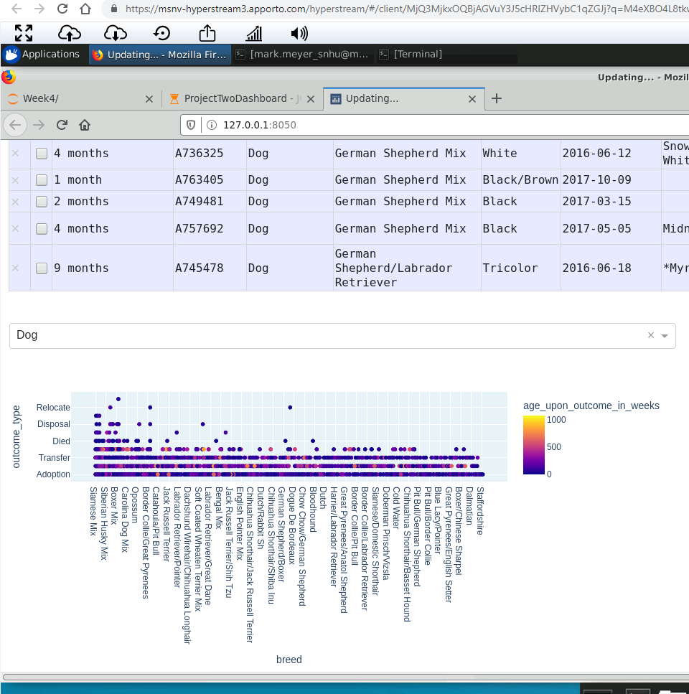

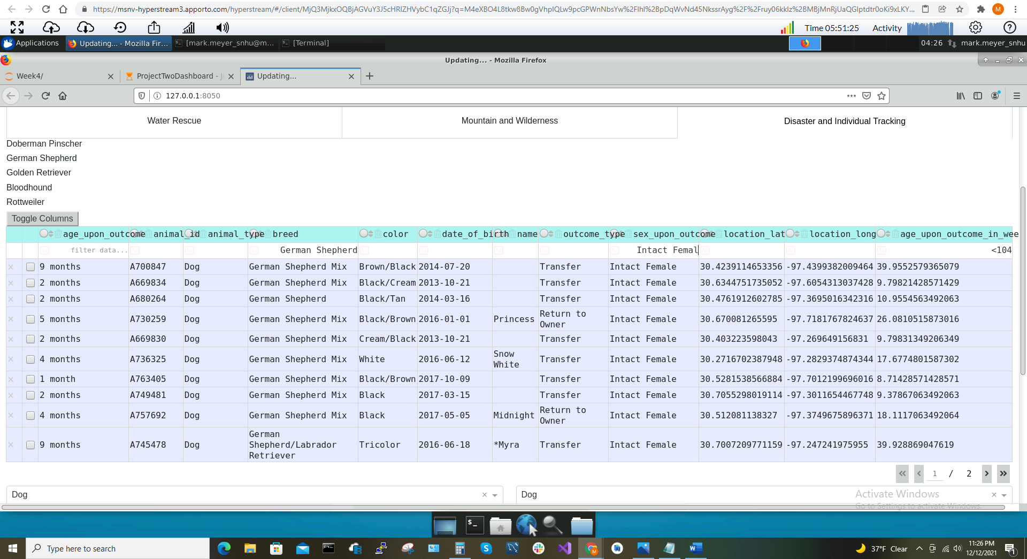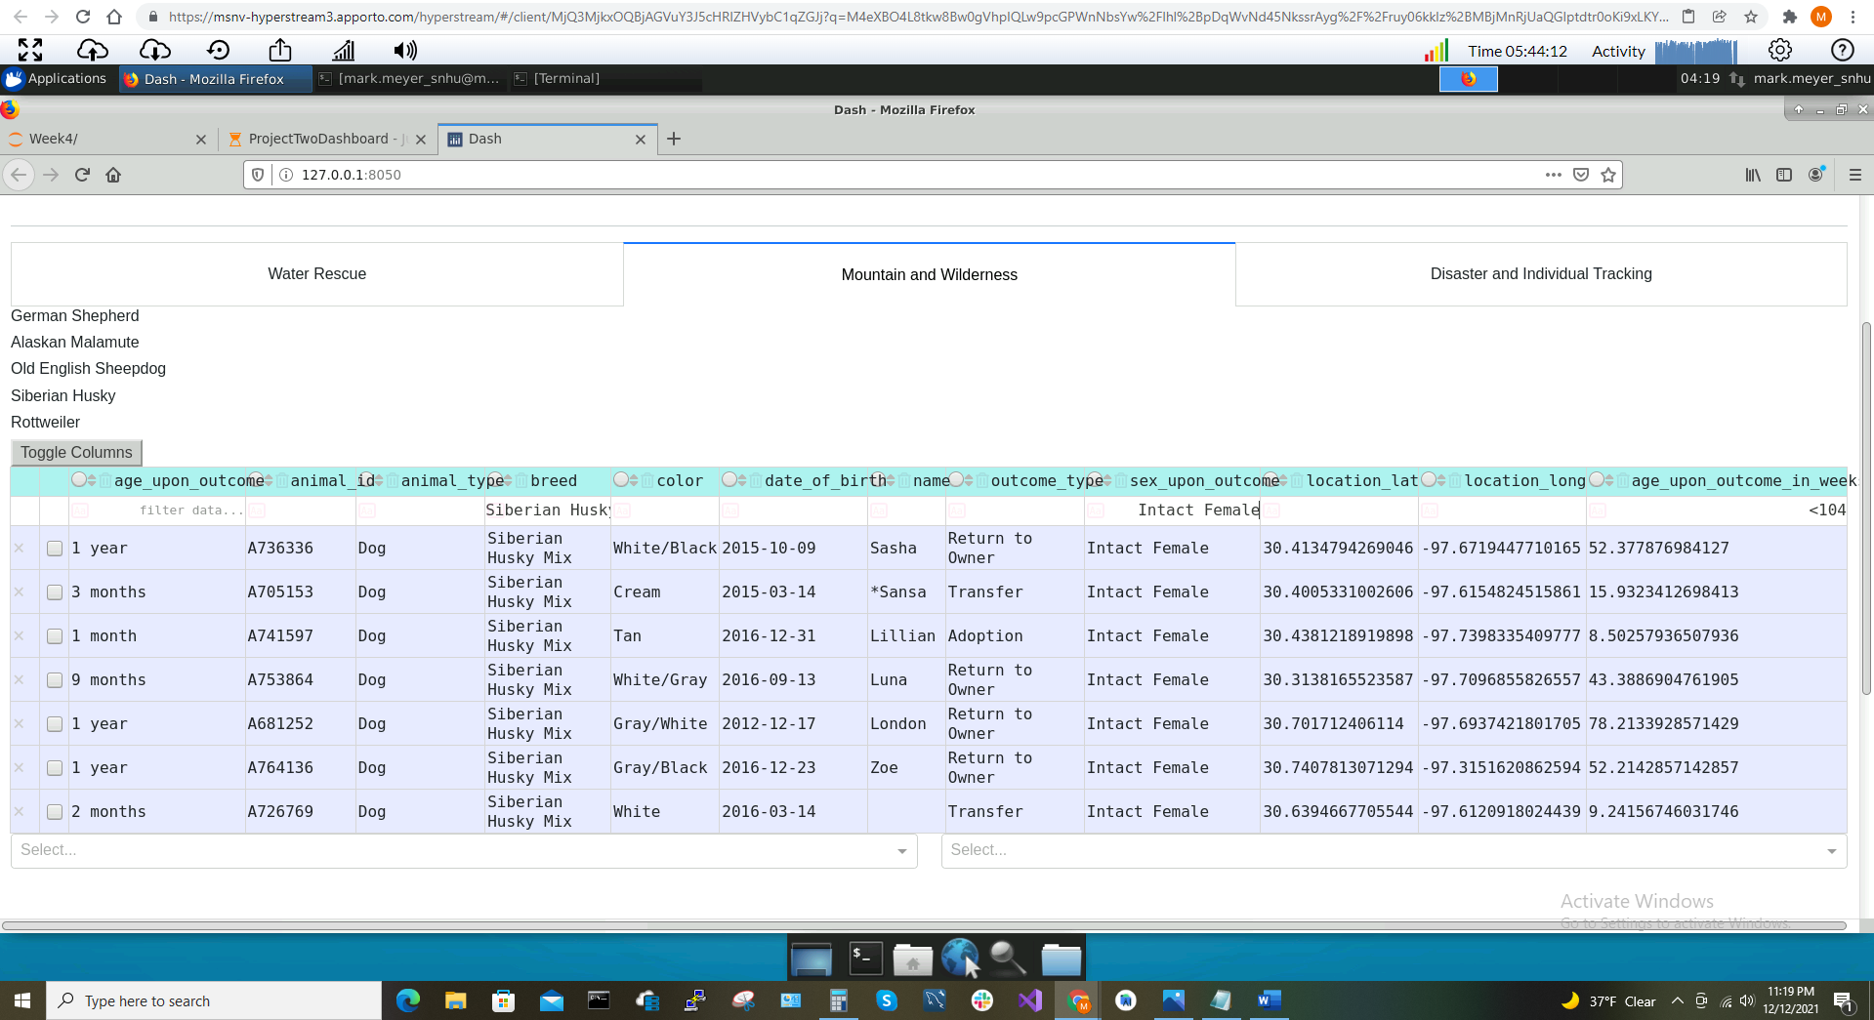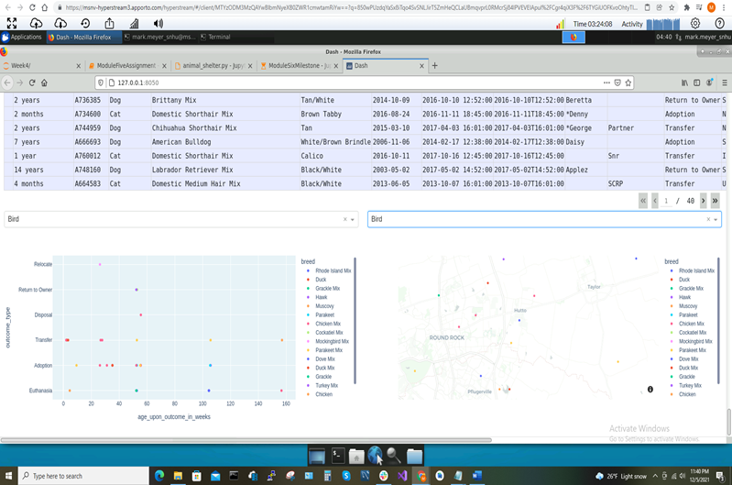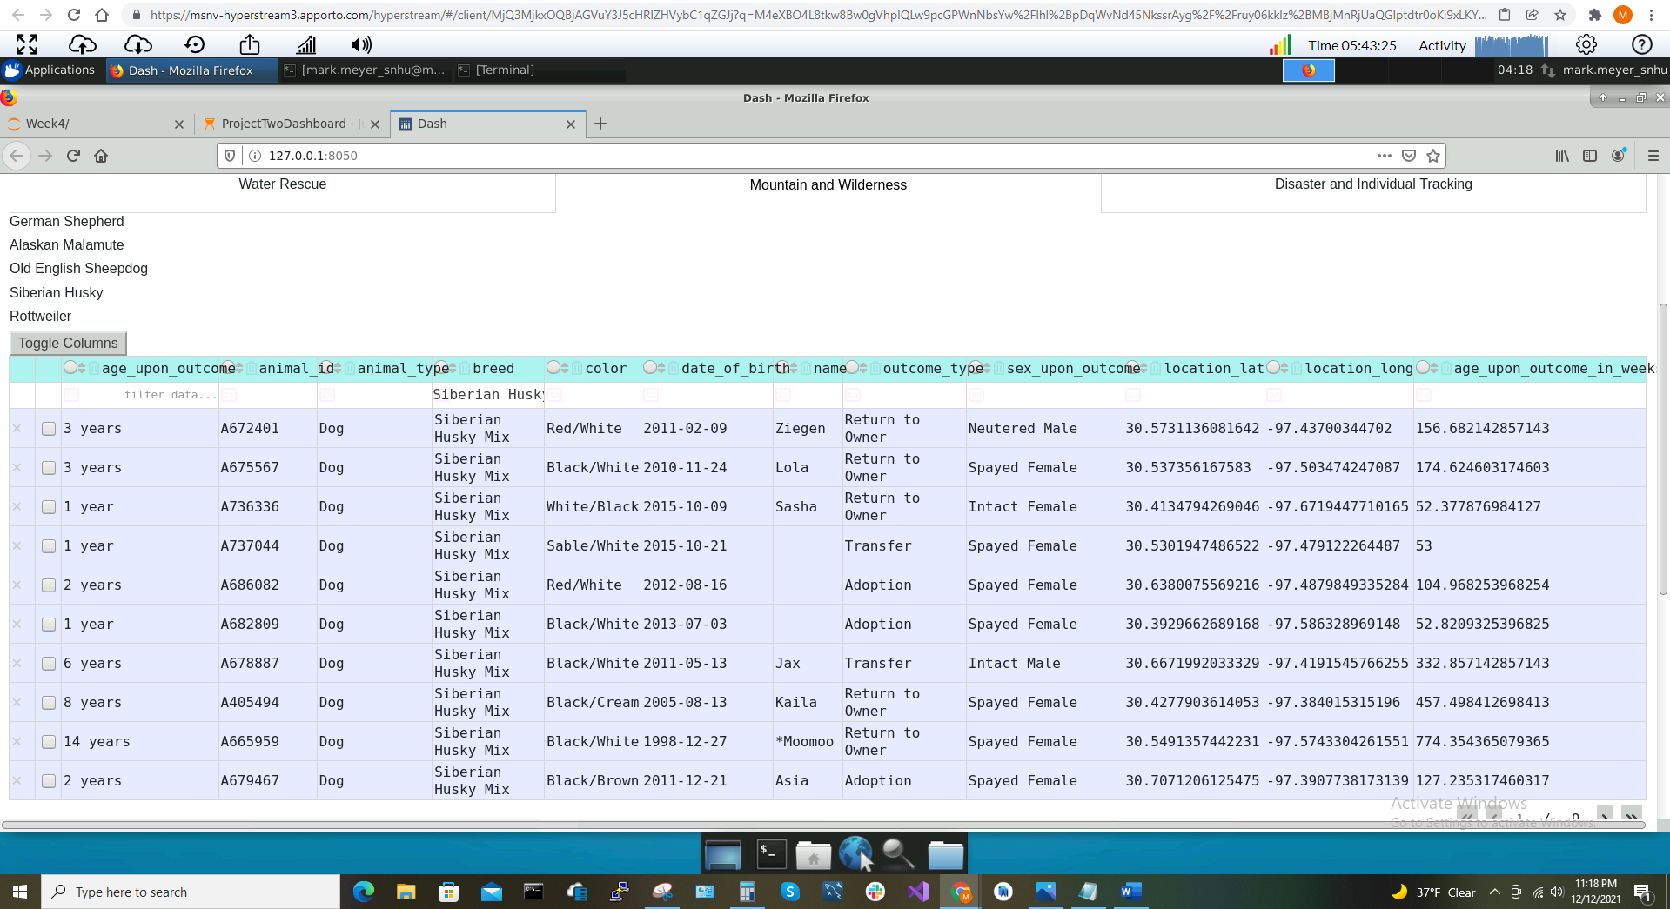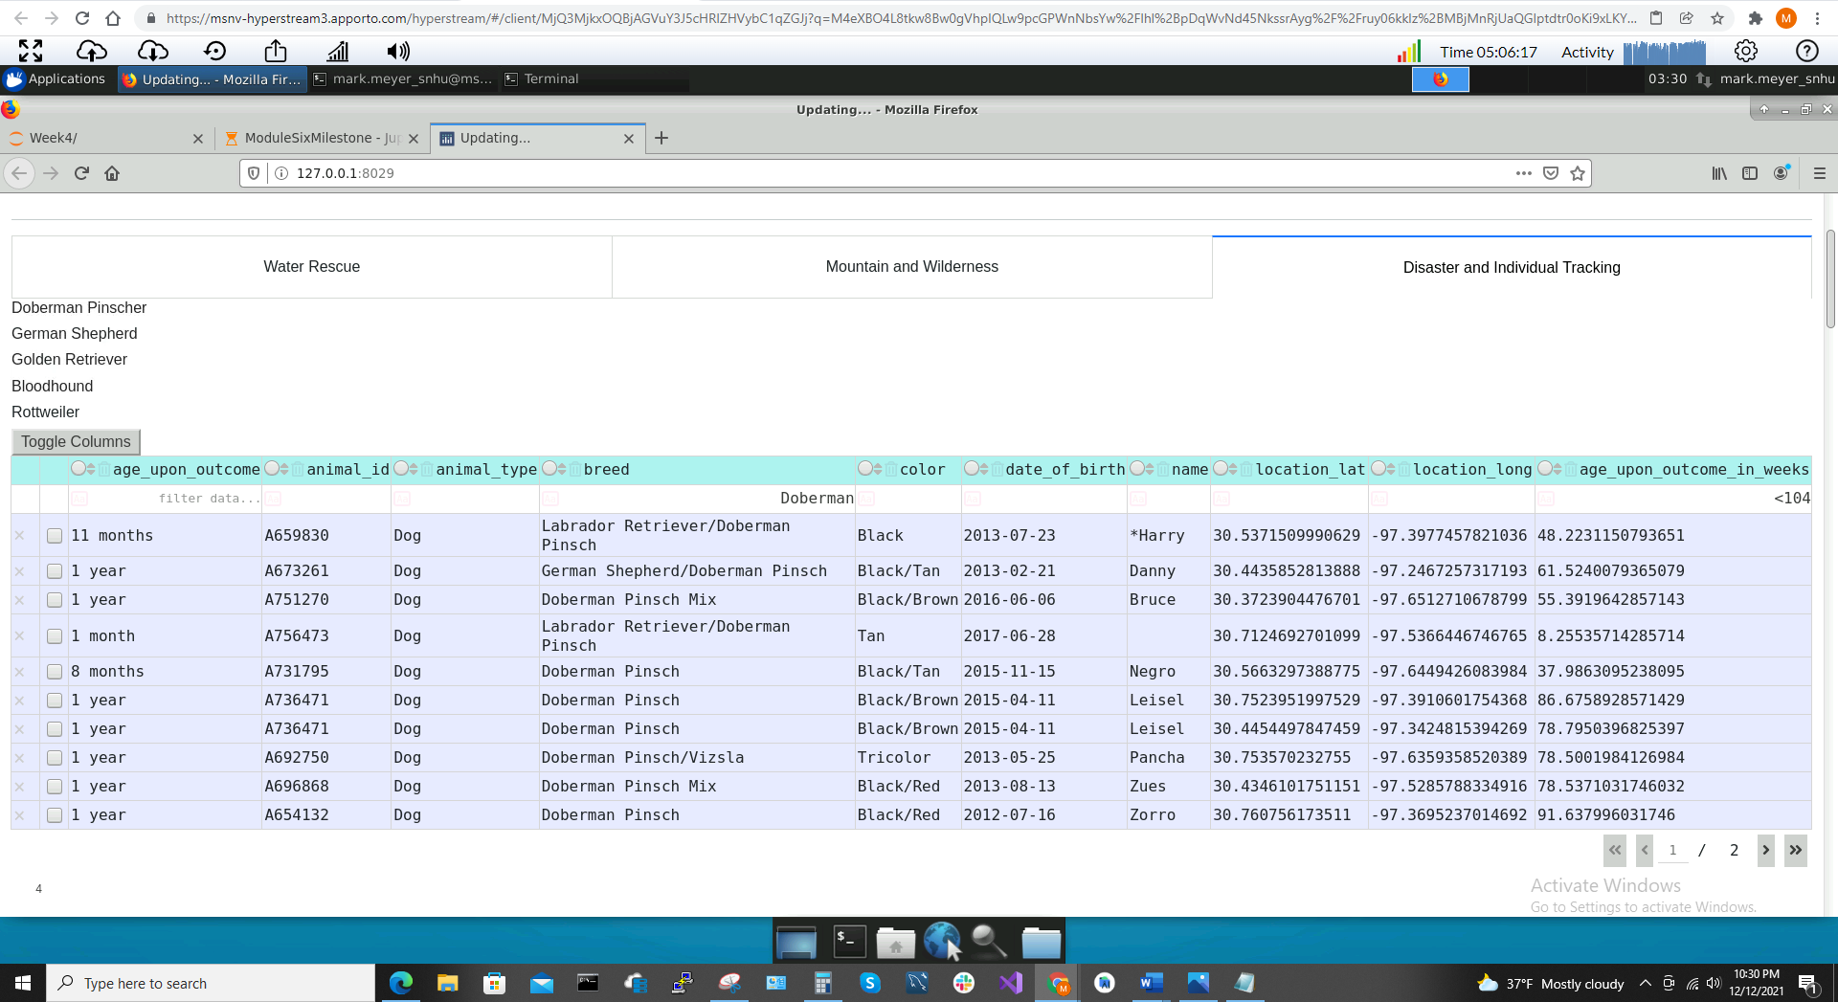

## As seen in the screenshots above, the dashboard has the Grazioso logo, the unique identifier alongside the developer’s name, and three tabs which each display the breeds of each corresponding rescue type. Using these breeds, the database can be filtered quickly and efficiently using multiple filters. The database shows only 10 rows at once, but does allow filtering every column at the same time. Additionally, the database is indexed by the animal type “Dogs” by default because this is what was requested by the customer, an interface to locate rescue dogs. There are some additional data charts at the bottom including a graph chart that allow the customer to aquire more in-depth analysis of their rescue research. It should be noted that the database also supports operators such that you may enter “< 104” in the “age_upon_outcome_in_weeks” column to look for dogs under 104 weeks old (under 2 years).

## Roadmap/Features (Optional)

This project includes the functionality of CRUD operations: ‘Create’, ‘Read’, ‘Update’, and ‘Delete’. This project stands out because it is ideal to automate tasks as much as possible to eliminate user error and to speed up productivity wherever possible.

## Contact

Mark W. Meyer, Software Engineer